Computer Searches

Advanced Search
To get a more specific search Click on Advanced Search and fill in the areas that you want to limit your search to.

Timeline
On the left side.
This feature allows you to see how things have changed over a specific time frame

Wonder Wheel
Google’s new feature called Google Wonder Wheel is another manner in which users can view their search results. It is unique as it presents a visual wheel of phrases that is related to the main search query.
Below is a step by step guide on using the Google Wonder Wheel
First, you enter a word or phrase into Google and perform the search. For this guide, we will just type in wedding dress to use as an example.
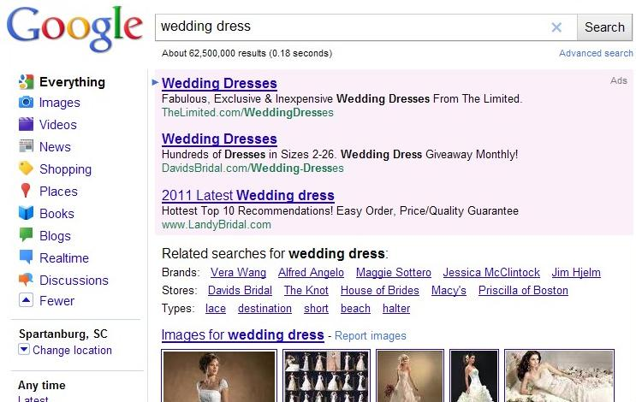
Once this step is completed, look on the left side and you will see an option that says “more search tools”.
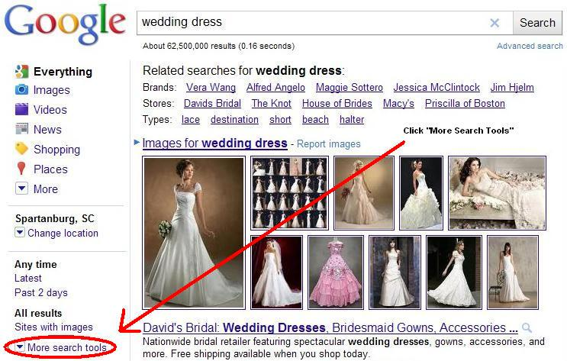
Within the list of options that Google has provided to help users search more efficiently is the Google Wonder Wheel. This wonderful option will display results that are relevant to your search in a unique manner. Keep in mind that the other new options are quite helpful as well so you can look into those after checking out the Wonder Wheel.
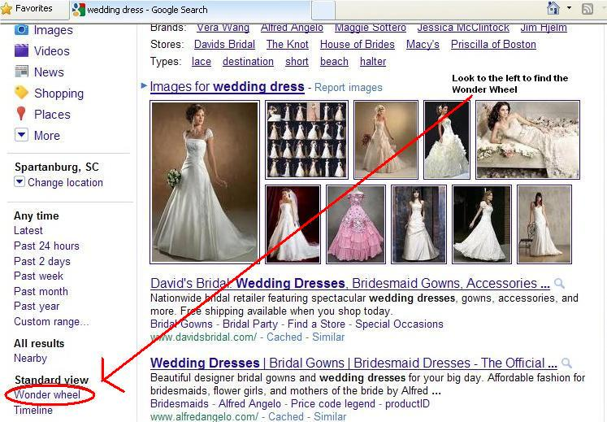
Now upon clicking on the Wonder Wheel option you will be presented with a circle like graph which contains the main search phrase in the middle and other related terms branched off from the circle. As you can see in the screenshot, our main search phrase, wedding dress, is in the middle of the graph while the related phrases are branched off surrounding the main phrase. On the right side of the Google Wonder Wheel you will see the normal search results.
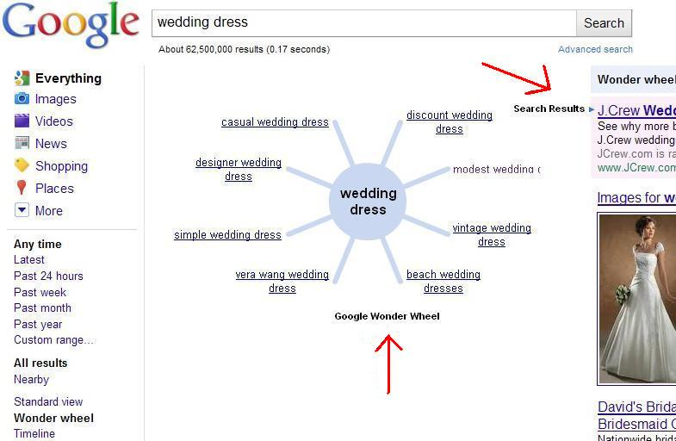
At this point, you can start to have a little fun. If you click on any of the related phrases in the wheel, you will be presented with more relevant results and the wheel will grow. It’s very simple and the visuals make it a lot more interesting. With the example we used, a simple search of wedding dress led us to modest wedding dress results and other results all relating to our main search.

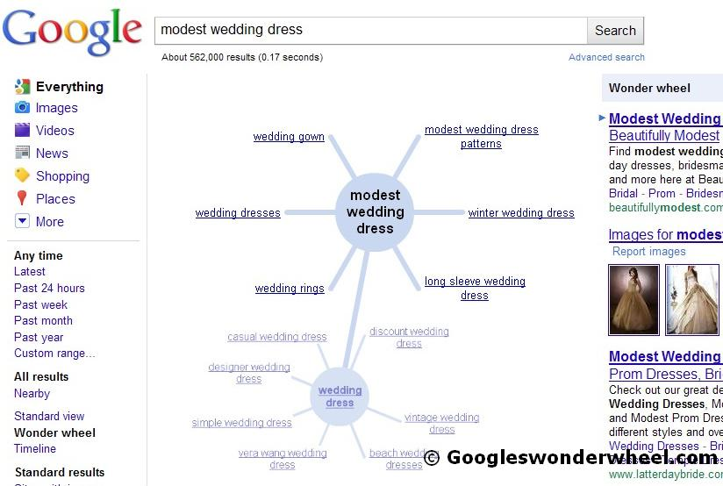
Using the Google Wonder Wheel is not only useful but fun as well. There is no telling what Google will incorporate with this amazing tool to make it even more fascinating and beneficial for searchers.

Google News
news.google.com/ - Cached
Aggregated headlines and a search engine of many of the world's news sources.
It's really quite simple. Simply go to news.google.com and type in what you would like to scour the news for. The results are displayed on the screen, but you can also save them as a custom RSS feed that will be continuously updated.
After going to news.google.com, type in what you want to search for and click the "Search News" button. This will tell Google to search through every website it has classified as either news or a blog and bring back results for your search.

Google Squared
www.google.com/squared - Cached
Google Squared takes a category and creates a starter 'square' of information, automatically fetching and organizing facts from across the web.
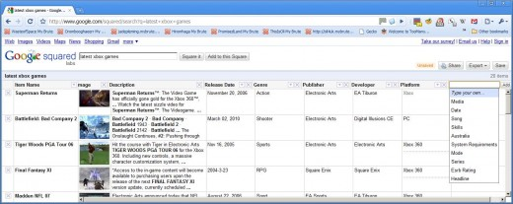

Google Books
books.google.com/
Search and preview millions of books from libraries and publishers worldwide using Google Book Search. Discover a new favorite or unearth an old classic.

Time Machine

Go to Yttm.tv
In the search box type what you are searching for and it will bring up tv and movies about that topic.

Spezify.com

This allows you to search pictures, video, and quotes on any topic you type in.

